

Project Initialization and Planning Phase

|  |  |
| --- | --- |
| Date | 20-06-2025 |
| Team ID | SWTID1749906902 |
| Project Name | Early Stage Disease Diagnosis System Using Human Nail Image Processing Using Deep Learning |
| Maximum Marks | 3 Marks |

**Define Problem Statements (Customer Problem Statement Template):**

The current early-stage disease diagnosis process poses challenges for individuals, particularly in terms of accessibility, accuracy, and convenience. Many people delay or avoid medical consultations due to time constraints, cost, or lack of awareness, leading to missed opportunities for timely intervention. Our proposed system—an early-stage disease diagnosis solution using human nail image processing powered by deep learning—aims to address these gaps. By leveraging non-invasive, image-based diagnostics, we can offer users a fast, accessible, and reliable screening tool. Understanding user concerns around medical testing and creating an intuitive, user-friendly interface will help improve trust, encourage proactive health management, and foster a positive perception of our healthcare innovation.

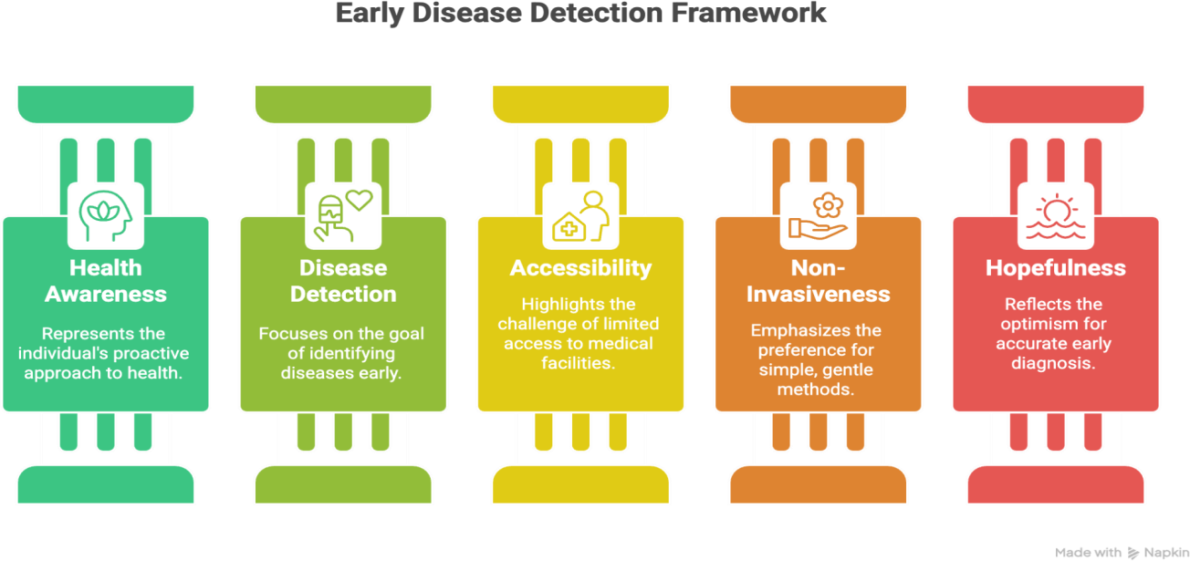

|  |  |  |  |  |  |
| --- | --- | --- | --- | --- | --- |
| **Problem**  **Statement (PS)** | **I am**  **(Customer)** | **I’m trying to** | **But** | **Because** | **Which makes me feel** |
| PS-1 | A health-conscious individual or patient. | Detect early signs of disease. | Lack access to affordable and easy diagnostics. | Nail appearance changes are often early indicators of disease. | Hopeful for an accessible and early diagnosis. |